Centrality Mapper User Guide
Version 2.0—Updated September 2017

Brad McRae
The Nature Conservancy

Acknowledgements
Centrality Mapper builds on much of the Python code developed with Darren Kavanagh for Linkage Mapper, and uses Circuitscape, developed with Viral Shah. I am grateful for Darren’s and Viral’s excellent contributions.

Software Requirements and Licensing
Centrality Mapper requires AcrGIS 10.0 with the Spatial Analyst extension. Circuitscape 3.5.8 or later must also be installed on your machine. This code is provided free of charge under a GNU General Public License. More details can be found on the Linkage Mapper website, where our code is hosted: http://www.circuitscape.org/linkagemapper.

Preferred Citation
McRae, B.H. 2012. Centrality Mapper Connectivity Analysis Software. The Nature Conservancy, Seattle WA. Available at: http://www.circuitscape.org/linkagemapper.

Table of Contents
1. Introduction 2
2. Installation 2
3. Using Centrality Mapper 2
3.1 Input data requirements 2
3.2 Running the toolbox 2
3.3 What Centrality Mapper does 3
4. Centrality Mapper tutorial 4
5. Support 5
6. Literature cited 5

1. Introduction
Centrality Mapper is part of the Linkage Mapper Toolkit, which includes Linkage Mapper (McRae and Kavanagh 2011) and other modules designed to support regional wildlife habitat connectivity analyses. Once corridors have been mapped using Linkage Mapper, Centrality Mapper analyzes the resulting linkage networks, calculating current flow centrality across the networks. Current flow centrality is a measure of how important a link or core area is for keeping the overall network connected.
More details on centrality analyses can be found in Carroll et al. (2012). More details on circuit theory and on Circuitscape software can be found in McRae et al. (2008) and McRae and Shah (2009) respectively.

2. Installation
1) Install the latest version of Circuitscape
Circuitscape can be downloaded from www.circuitscape.org. If you are running 64-bit windows, make sure to install the 64-bit version.

2) Install the ‘Linkage Mapper Arc10’ toolbox.
Follow the instructions in the Linkage Mapper User Guide to install the toolbox.

3) Verify your installation
You can test the code by running the tutorial below.

3. Using Centrality Mapper

3.1 Input data requirements
Centrality Mapper uses the link maps (‘stick’ and least-cost path maps) produced by Linkage Mapper and stored in the output directory, plus the link tables saved in the datapass directory. You only need to provide the project directory and the core area file.

3.2 Running the toolbox

Note: ArcGIS can be finicky about file locks. If you get schema lock or permission errors, you may need to close ArcCatalog and ArcMap and start fresh without any output files displayed.

Note: Although this user guide was written with running from ArcMap in mind, several users have reported that they experience fewer ArcGIS errors when running from ArcCatalog. We therefore suggest you run from ArcCatalog if you are having problems with the tool.
Click on the Centrality Mapper tool, which is located inside of the Linkage Mapper Arc 10 toolbox. The following dialog should appear.

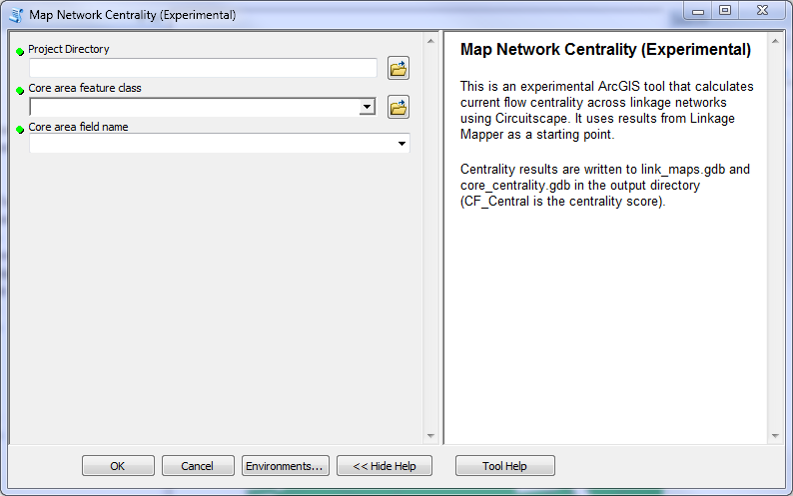
Figure 1. Centrality Mapper dialog.

Input data
  - Project directory: Use the same project directory used for the Linkage Mapper run.
  - Core area feature class: Use the same core area file you used to create corridors using Linkage Mapper.
  - Core area field name: Use the same core area field name you used to create corridors using Linkage Mapper.

3.3 What Centrality Mapper does
Centrality Mapper reads in the vector outputs (least-cost path and stick maps) from Linkage Mapper. It then calculates current flow centrality on the linkage network using Circuitscape (McRae and Shah 2009). Each core area is treated as a node, and each link is assigned a resistance equal to the cost-weighted distance of the corresponding least-cost corridor. Centrality Mapper then iterates through all core area pairs, injecting 1 Amp of current into one core area and setting the other to ground. It adds up the results across all core areas and links to generate a centrality score.

Outputs are written to link_maps.gdb and core_centrality.gdb in your output directory. The file names in link_maps.gdb are unchanged, but an attribute is added to each link with a centrality score. A copy of the core area feature class will be written to the core_centrality.gdb with a centrality score attribute added.

4. Centrality Mapper tutorial
After running the Linkage Mapper tutorial, you can analyze network centrality on the linkage network it created. Open up LM_demo_results.mxd, and run Centrality Mapper using the following settings.
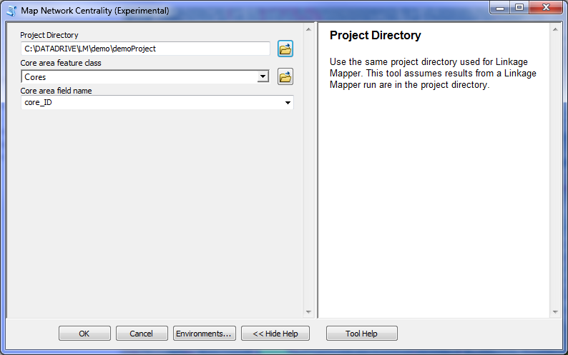
Figure 2. Tutorial settings. Substitute the path to the location of your own demoProject directory.

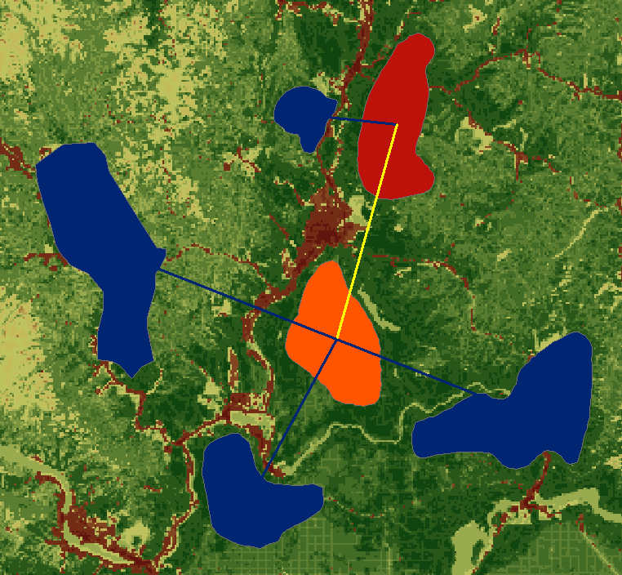
Figure 3. Tutorial outputs, found in link_maps.gdb and core_centrality.gdb. Link colors indicate link centrality score (the yellow link has a higher score than the others because its loss would disconnect more than one core area from the rest of the network). Core area colors indicate core area centrality; the orange core has the highest centrality because it is a ‘hub’ for keeping the network connected. The red core has a higher centrality score than the blue cores because its loss would disconnect more than one core area from the rest of the network.

5. Support
Please join the Linkage Mapper User Group to get updates, report bugs, and suggest enhancements. You can find a link to the user group on the Linkage Mapper website, where our code is hosted: http://www.circuitscape.org/linkagemapper.

6. Literature cited
Carroll, C., B.H. McRae, and A. Brookes. 2012. Use of linkage mapping and centrality analysis across habitat gradients to conserve connectivity of gray wolf populations in western North America. Conservation Biology 26(1):78-87.
McRae, B.H., B.G. Dickson, T.H. Keitt, and V.B. Shah. 2008. Using circuit theory to model connectivity in ecology, evolution, and conservation. Ecology 10: 2712-2724.
McRae, B.H., and Shah, V.B. 2009. Circuitscape User’s Guide. ONLINE. The University of California, Santa Barbara. Available at: http://www.circuitscape.org.
Washington Wildlife Habitat Connectivity Working Group (WHCWG). 2010. Washington Connected Landscapes Project: Statewide Analysis. Washington Departments of Fish and Wildlife, and Transportation, Olympia, WA. Available at: http://www.waconnected.org.

